Halfmerke Primary School
August Newsletter

Dear Parents and Carers
Welcome back! I hope all our families had a wonderful summer and enjoyed spending time with family and friends. The children have all settled in well to their new classes and are getting used to the new routines. I have included a few helpful reminders to help your child organised themselves and be ready for learning. In this newsletter I have included diary dates coming up and some important info on events. Our new School Captains and House Leaders will be invited along to our first Halfmerke Havers of the session and you will have the opportunity to look at our School Improvement Plan for session 2023/24, hope to see some of you there! We are hopeful to get some parent/carer volunteers in to help support the learning in school, if you are interested, please see the info below. As always thank you for your continued support.

Ms L Hogg
Headteacher

Helpful Hints
- Please label everything, including packed lunch boxes.
- Try and keep your child’s snack separate from their lunch.
- Talk through lunch choices with your child the night before school - https://www.southlanarkshire.gov.uk/primary-menu.
- Ensure your child brings a waterproof jacket.
- Flip top water bottles are more appropriate for school and should be filled at home each morning.
- Ensure your child has indoor shoes which are stored at school.

Diary Dates
07.09.23 Parent Council Welcome Back Disco
08.09.23 Halfmerke Havers
13.09.23 Football Festival
28.09.23 Meet the Teacher Event 3:15 – 3:45pm, 4:00 – 4:30pm

Please take a note of your child’s class PE days.

Room 1 – Wed & Fri Room 5 – Mon & Wed
Room 2 – Tues & Wed Room 6 – Wed & Fri
Room 3 – Mon & Tues Room 7 – Wed & Fri
Room 4 – Tues & Thurs Room 8 – Wed & Thurs

Parentsportal
Parentsportal is now live in South Lanarkshire schools for primary and secondary school-aged pupils. Access online services such as consent for school trips, annual data checks, and view the school calendar, timetables, and school reports. Download the app and sign-up. More info at https://orlo.uk/En73o
Meet the Teacher
We would like to invite all our families to our Meet the Teacher event in school on Thursday 28th of September. You will get the opportunity to meet your child’s new teacher and learn a bit about the routines of the class. This event is for information of your child’s new class only and not a formal reporting event therefore there will not be an opportunity to discuss individual children. There will be two identical sessions to cater for siblings in the school. Feel free to attend any one at any time.
We hope to see lots of you there!

Showcase of Learning
This year we will be holding a Showcase of Learning for each class. This will allow families the opportunity to come into school and spend some time with your child’s class to celebrate their learning. This will take the form of either an assembly or a showcase in your child’s class or a mixture of both. We will include a list of dates in our next newsletter so you can ‘save the date’.

Parent Helpers – We are grateful for any parent or carer that can give up some spare time to pop in and help support the learning at Halfmerke. It is required that you complete a PVG application, and we have these in the office to give out if you need a form. Please email or give us a phone and we can chat about your availability.
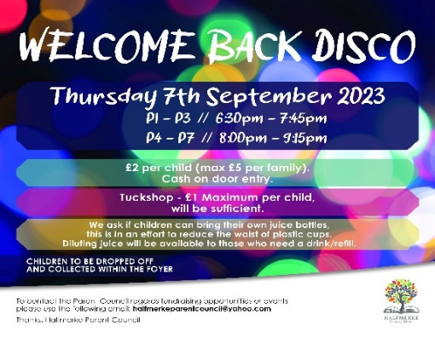

Parent Council News
Our Parent Council are hard at work organising the first Fundraising event of the year. A Welcome Back Disco has been organised for Thursday 7th September. Please see the information below.

Extra-Curricular Clubs
Our programme of extra-curricular clubs should be finalised in the next few weeks. For now, we are offering Netball and Athletics for our P6 & P7 pupils, and you will shortly receive further information on these as well as Boys/girls football and Dance. These clubs will participate in the SL Sport & Leisure events mentioned in the diary dates section. Please look out for further info regarding clubs for other stages of the school. We would love if there were any budding volunteers out there who are interested in either running a club or helping with one, if you are please get in touch with the school office. Our Active Schools Coordinator is on hand to offer support to anyone willing to help.

Communication
We are in the process of setting up Google Classrooms for your child’s class. This will be a way to communicate information and homework to your child. Over this year we are developing our School Blog so that we can provide you with weekly updates on what’s happening in your child’s classroom. If you have any concerns or queries about your child’s learning, please email or call the school office. This will be passed onto your child’s teacher or Ms Hogg/Miss Byrne, and someone will get back to you.
Twitter – Each class has their own Twitter page which is currently regularly updated for you to check in with. Search for Halfmerke Room __ (your child’s room number)

