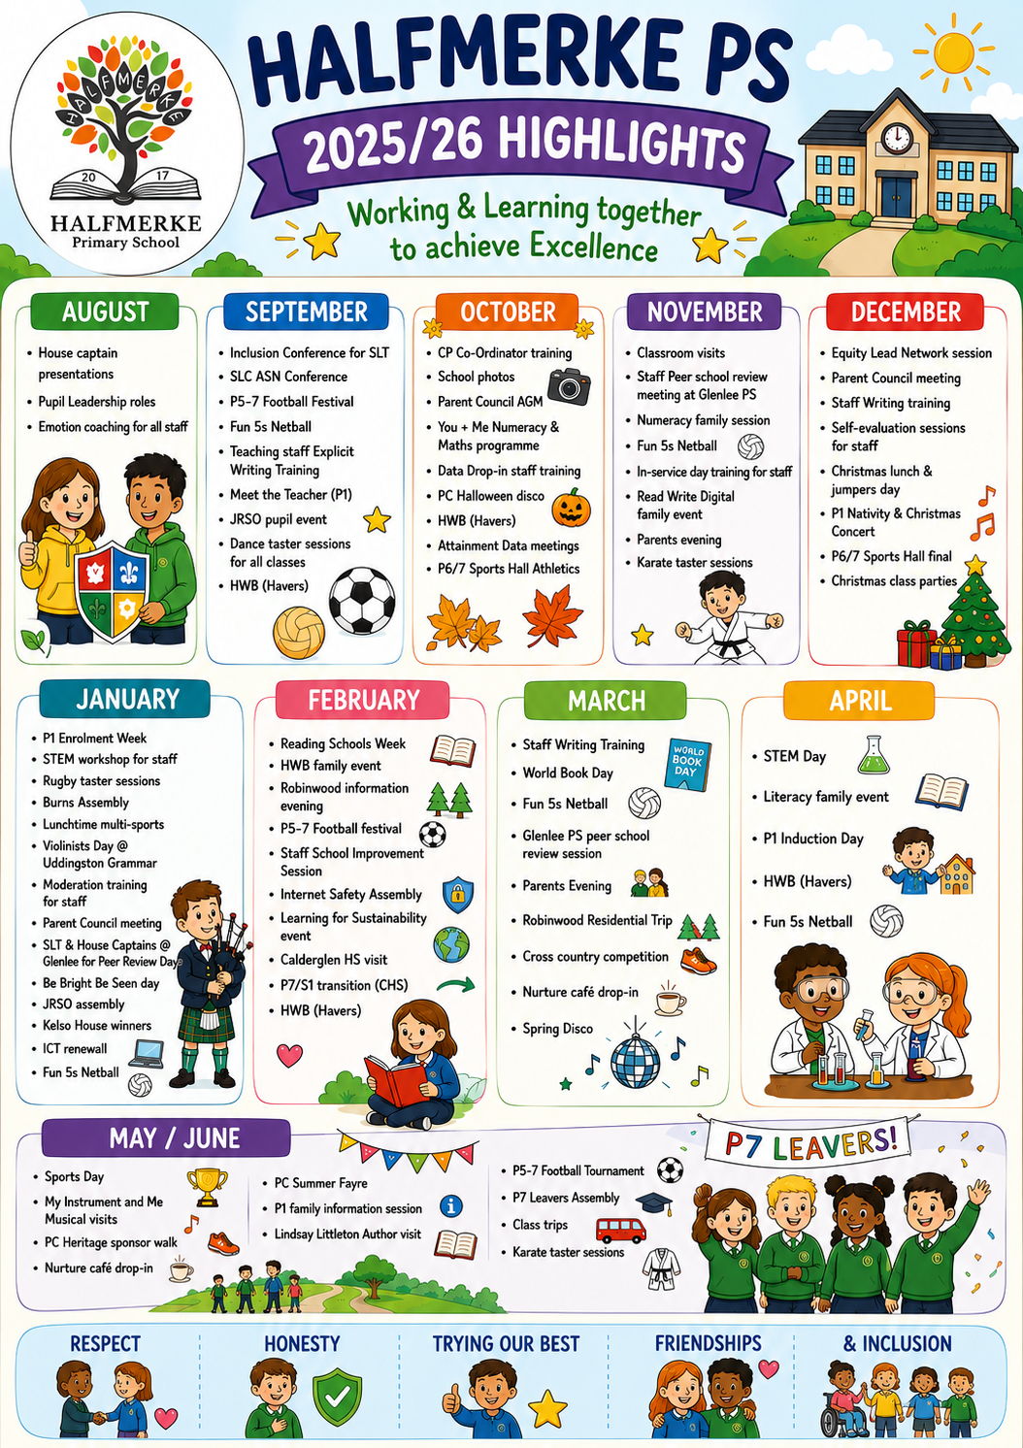
Improvement Planning and Standards and Quality Reporting for 2025/2026
Priority 1: To embed skills-based learning at all levels across the curriculum.
Progress and Impact

Since August 2025, the school has made strong progress in establishing the foundations of the South Lanarkshire Council Skills Framework.

By October 2025 – Early Implementation Phase.
- Staff engaged with and developed awareness of the SLC Skills Framework.
- CLPL opportunities supported increased professional understanding of skills development
- Initial audits enabled staff to reflect on existing practice
This phase was largely achieved effectively, as reflected in survey data showing improved confidence in:
- Understanding the purpose of the framework
- Awareness of key skills
Staff moved from limited awareness to informed understanding.

October 2025 – March 2026 (Ongoing Implementation)
Strengths / Achieved Areas
- Skills Framework resources are increasingly visible within classrooms
- Staff are beginning to integrate skills into learning, teaching and assessment (LTA)
- Learners are experiencing more opportunities to develop skills through planned learning

Skills are starting to feature beyond the classroom in pupil leadership, wider achievement and school life experiences. These developments are reflected in improved staff confidence in embedding skills into lessons, discussing skills with learners and increasing learner engagement.

Partially Achieved Areas
- Consistency in planning for progression of skills across stages
- Assessment and tracking of skills development over time
- Use of skills to inform next steps in learning
While staff are embedding skills more confidently, practice is not yet systematic or consistent across all classes and is still developing in terms of depth and measurable impact

Less Developed Areas
- Structured tracking and monitoring systems
- Robust approaches to skills assessment
- Full engagement with parents and stakeholders
- Use of partnerships to extend skills development opportunities

These areas remain at an early stage of development and now represent key priorities.

Since August 2025, staff confidence in using the South Lanarkshire Council Skills Framework has improved significantly. Practitioners have moved from an initial awareness stage to a more embedded approach, with clear evidence of skills being incorporated into learning, teaching and classroom dialogue. Learners are increasingly engaging with the language of skills and are beginning to articulate their understanding.

The school has made good progress in implementing the SLC Skills Framework, particularly in building staff awareness and beginning to embed skills within learning and teaching. There is clear evidence that skills are becoming more visible in classrooms and that learners are increasingly engaging with the language of skills.

Improvement Planning and Standards and Quality Reporting for 2025/2026
Priority 2: To embed Explicitly Teaching Writing Pedagogy and Maths Recovery approaches at all stages.
Progress and Impact

Raising attainment in Writing

There has been significant whole-staff progress in confidence and competence when delivering explicitly taught writing. Initial uncertainty and limited experience (August 2025) has developed into a much stronger, more consistent understanding by March 2026. Staff are now more confident in planning, modelling and scaffolding lessons, and there is a clear shared belief in the positive impact on learners.

The data shows clear, measurable improvement in teacher confidence and strong uptake of the explicitly teaching writing approach. The next phase should focus on depth, consistency, and differentiation, ensuring all learners benefit and staff move from confident delivery to expert practice.

Analysis of whole-school attainment data demonstrates a clear, sustained improvement in writing across the academic year. Attainment has increased progressively from 66.3% in August, to 67.3% in November, 70.2% in February, and reaching 77.5% by June.

This represents an overall increase of 11.2 percentage points, indicating strong and accelerating progress over time. Early gains between August and November were modest, reflecting the initial stages of implementation. However, the more substantial increases between November and June suggest that as staff confidence, consistency and understanding of explicitly teaching writing have developed, this has translated into significant improvements in learner outcomes.
The most notable improvement occurs between February and June, highlighting that the approach is now becoming embedded and having a sustained impact across all stages. This trend suggests that teaching practices are becoming increasingly effective, with learners demonstrating greater independence, confidence and competence in writing.
Overall, the data indicates that the school is making very good progress in raising attainment in writing, with a strong trajectory towards continued improvement. Moving forward, the focus should be on sustaining this momentum, ensuring consistency across all classes, and continuing to support both challenge and differentiation to maximise attainment for all learners. Moving forward, the school should focus on sustaining early gains, re-accelerating progress at P4, and maintaining high expectations at P7, ensuring that all learners continue to make consistent and meaningful progress in writing.

While progress is evident, attainment remains an area for continued focus to ensure that all learners achieve expected levels, particularly through strengthening independence and differentiation within writing lessons.

Overall, the data demonstrates that the explicitly teaching writing approach is having a positive impact across all stages, with particularly strong gains in P1 and P7. Moving forward, the school should focus on sustaining early gains, re-accelerating progress at P4, and maintaining high expectations at P7, ensuring that all learners continue to make consistent and meaningful progress in writing.

While progress is evident, attainment remains an area for continued focus to ensure that all learners achieve expected levels, particularly through strengthening independence and differentiation within writing lessons.
Overall, the data indicates that the school is moving in a positive direction, with strong foundations now in place to support continued improvement in writing attainment across all stages.

Raising attainment in Numeracy

The school is beginning to make progress in embedding the Maths Recovery (MR) approach across learning, teaching and assessment, with evidence suggesting that implementation has moved from initial exploration towards more consistent and collaborative practice. There is increased engagement and readiness in practice across most stages, although consistency in practice was still developing.

More activities such as staff confidence surveys, pupil work audits and professional learning through targeted training is required to create a clear foundation for improvement. Collegiate working to design consistent planning approaches need to be prioritised to ensure a shared understanding and coherence.

QA activities have evidenced a deepening practice and increasing professional collaboration. Peer and trio visits to share best practice, alongside ongoing professional dialogue and assessment of pupil work are now required to demonstrate a shift from theory to classroom application. The introduction of structured supports (e.g. success criteria and targeted resources) would further strengthened consistency.

Engagement with families through information sessions highlights a broader embedding of the approach beyond the classroom.

MR approach is becoming embedded in day-to-day practice. Teachers are beginning to plan and deliver learning using MR principles, with an emphasis on formative assessment, feedback, and targeted intervention to raise attainment. A more consistent use of MR approaches for identified learners, alongside ongoing assessment and SLT engagement, will demonstrate a more strategic and data-informed implementation.

Overall, the school has progressed from building awareness and capacity to beginning to embed consistent, high-quality MR-informed practice.

Attainment in numeracy across P1–P7 demonstrates a clear and sustained upward trajectory over the course of the academic year. Starting at 70.4% in August, attainment rose to 71.9% in November, then to 73.7% in February, and reached 77% by June. This represents an overall increase of 6.6 percentage points, indicating strong improvement over time. The steady gains at each data point highlight that progress has been incremental, consistent, and secure, rather than fluctuating. The most notable acceleration occurs between February and June, suggesting that approaches implemented in the latter part of the year—particularly targeted support and embedded practice—have had a significant positive impact on pupil attainment. Overall, the data reflects solid progress and improving outcomes in numeracy across the school, with a clear trend of sustained improvement from baseline through to the end of the session.

Overall, the data reflects strengthening attainment across the school, with a clear trajectory of improvement as the session progresses.

Improvement Planning and Standards and Quality Reporting for 2025/2026
Priority 3: Inquire to Inspire/Curriculum Rationale
Progress and Impact

Progress towards implementing Inquiry-Based Learning (IBL) across the school shows early-stage development with emerging strengths, alongside clear next steps for consistency, confidence and whole-school alignment.
Staff engagement with professional learning has been positive. All staff have attended CLPL linked to the SLC Inquire to Inspire Framework, resulting in an increased understanding of the theoretical principles underpinning inquiry and interdisciplinary learning. This reflects the expectation within the SLC guidance that practitioners develop a secure understanding of inquiry as both a pedagogical approach and mindset rather than a discrete subject. Staff are now familiar with the SLC guidance and have begun to explore elements of the Inquiry Cycle, which provides a structured framework for learning through questioning, investigation and reflection.
There is evidence of initial implementation in practice. All classes piloted an inquiry-based project in January, aligning well with planned operational activities. Staff also reviewed the current IDL offer, demonstrating reflective practice and recognition that existing approaches must evolve to enable deeper, more meaningful interdisciplinary learning, as recommended in national guidance. Professional dialogue during CAT sessions further supported staff to share experiences and identify next steps, particularly in relation to progression across CfE levels.
However, this progress remains inconsistent and at an early stage of embedding. Staff confidence in applying inquiry-based approaches and using the Inquiry Cycle is still limited. This reflects wider challenges noted in the SLC strategy, where practitioners often require structured support, shared language, and time to develop confidence in designing and facilitating inquiry. The absence of peer visits this session has reduced opportunities for practitioners to observe effective practice in action, which may have slowed the development of confidence and consistency across the school.
Monitoring and evaluation processes are not yet sufficiently robust. While some staff used the Leuven Scale to assess pupil engagement, this was not applied consistently across the school and insufficient data was gathered to allow for meaningful analysis or to track impact over time. This limits the school’s ability to evidence the impact of inquiry-based learning on engagement and outcomes, despite research highlighting its potential to improve both.
In terms of planning and coherence, there is clear recognition that further development is required. Although staff have begun to explore inquiry approaches, there is not yet a consistent, whole-school model in place. The need for increased collaborative planning time has been identified as a key barrier. As highlighted within the SLC guidance, effective inquiry-based learning depends on coherent, interdisciplinary planning and shared approaches across stages, rather than isolated projects. The proposed creation of a whole-school planner is therefore a positive and necessary next step to support progression, coverage of Experiences and Outcomes, and consistency in practice.
Pupil voice is beginning to be incorporated, with learners involved in planning within classes. This aligns with the principles of inquiry-based learning, where learners take an active role in shaping their learning through questioning and investigation. However, this remains underdeveloped, and further work is required to ensure that pupil voice meaningfully influences learning across all stages and is embedded as a core feature of inquiry.
Overall, the school has made satisfactory progress in building awareness and initiating practice in inquiry-based learning. Strengths include:
- Increased staff knowledge and engagement with professional learning
- Initial piloting of inquiry projects across all classes
- Reflective dialogue identifying key next steps
- Emerging use of pupil voice
However, to move from emerging practice to effective and sustained implementation, key areas for development include:
- Building staff confidence and consistency in using the Inquiry Cycle
- Developing a clear, whole-school approach to planning and progression
- Strengthening collaborative professional learning and opportunities to observe practice
- Embedding robust approaches to monitoring impact, including consistent use of engagement measures
- Enhancing pupil voice to ensure learners are leading and shaping inquiries

PEF Improvement Planning and Standards and Quality Reporting for 2025/26
Progress and Impact

ACEL data recorded in the Priority 2 progress and impact column details gains in both these areas across all stages.
The results for targeted learners receiving interventions in spelling and reading from June 2026 show a noticeable change compared to June 2025. Overall, there has been an improvement with more learners achieving their target/expected level than in the previous year. This suggests that the strategies implemented over the past year, such as IDL, Nessy & 5 Minute Box, have had a positive impact.
A comparison of assessment data from June 2025 and January 2026 shows that all children made measurable progress over the period. The results indicate a positive impact of targeted interventions, with improvements observed across the cohort.
The results highlight:
- Consistent improvement across all learners
- Greater gains for some pupils, suggesting particularly effective engagement with the intervention
- A need for ongoing targeted support for pupils with lower percentage increases

In conclusion, the January 2026 data shows clear progress from the June 2025 baseline, indicating that the interventions in place have been effective in supporting literacy development, with continued differentiation required to maximise outcomes for all learners.
IDLS Literacy Intervention – Comparative Summary (June 2025 → June 2026)
Overall, the data shows strong progress in both reading and spelling across nearly all pupils, with the majority demonstrating measurable gains over the assessment period.
Reading Progress

- Most children made positive gains in reading age, ranging from +1 month to over +2 years.
- A significant number of pupils (particularly in P3–P5) made accelerated progress (1+ year gains).
- A few pupils showed minimal or no increase, but these were in the minority.

Spelling Progress
- Spelling gains were also strong, with many pupils achieving 6 months to 2+ years progress.
- Several pupils made exceptional gains exceeding 1 year, particularly in P3–P5.
- A small number of pupils showed no change or slight regression, but this was limited.

Overall Impact
- The IDLS intervention has had a highly positive impact on literacy attainment.
- Most pupils are making progress above expected rates, particularly in reading.
- The data demonstrates:

Consistent improvement across stages
Significant acceleration for targeted pupils
Closing of attainment gaps for several learners

5 Minute Box Progress Summary (November–June)
Analysis of the 5 Minute Box data from November to June shows a clear overall pattern of progress across most pupils, with gains evident in reading age, spelling, and/or comprehension measures. The majority of learners made measurable improvements over the period, with several demonstrating accelerated progress beyond expected rates.
Across Primary 2 and Primary 3, many pupils made between 8 months and 1 year+ of progress within the tracking window, indicating strong impact from regular, structured engagement with the 5 Minute Box. A smaller number of pupils achieved significantly accelerated progress (over 1 year 6 months), particularly in combined literacy measures, suggesting high levels of responsiveness to the intervention.
75% of the children showed improvement in both reading and writing.
In this academic year there has been a decrease in children with high levels of developmental difficulty and an increase in those showing no apparent developmental difficulty. Children who previously required significant support (ACE) have reduced their nurture provision from daily to weekly sessions.
There has been a decrease in the number of children displaying diagnostic difficulty which indicates that appropriate measures are in place within the school to support their additional needs. Many of these children received 45 minutes of nurture provision daily through a lunchtime club, which has impacted positively.
Boxall Profile Online snapshot from August 25 – June 26 indicates;
- 17% increase in children with no apparent developmental difficulty.
- 50% increase in children with no apparent diagnostic difficulty.

