

Standards and Quality Report 2023-2024


Halfmerke Primary School

Vision and Values
We aim to ensure that every child has a broad and general education with literacy, numeracy and health and wellbeing at the centre of our curriculum. We value meaningful learning for all our pupils and our aim is that every child is supported to reach their potential both in their academic learning and wellbeing by providing them with a range of activities and opportunities in all curricular areas.

At Halfmerke Primary, we are committed to working with families and work closely with our Parent Council who support us in school improvements and fundraising.

We are committed to raising attainment of all learners and have focus on raising attainment in literacy and numeracy as well as promoting and supporting wellbeing for all. We endeavour to fully support pupils through early indication and ensuring appropriate interventions are in place.

We want our pupils to become Confident Individuals, Successful Learners, Responsible Citizens and Effective Contributors and we support each one to be the best they can be.

Our school rules are to

Be Safe
Be Respectful
Be Ready

And we place importance on our shared school values to promote a safe, inclusive and positive environment for all staff and pupils.

Respect Honesty Trying our Best Friendships Inclusion

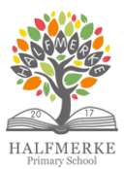

‘Working and learning together to achieve excellence’

Message from the Head Teacher
2023/24 has been a very successful year for Halfmerke Primary please see some of our highlights below.
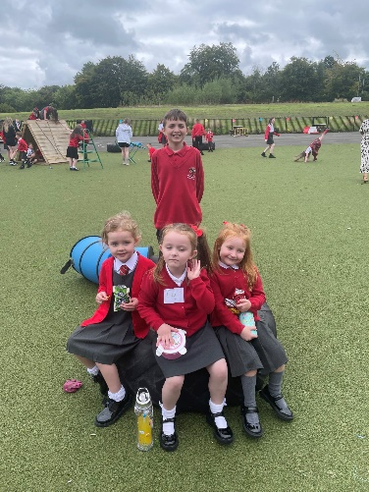
Our P7s participated in Buddy Training delivered by a Parent Volunteer. The helped to look out for our new P1 pupils.

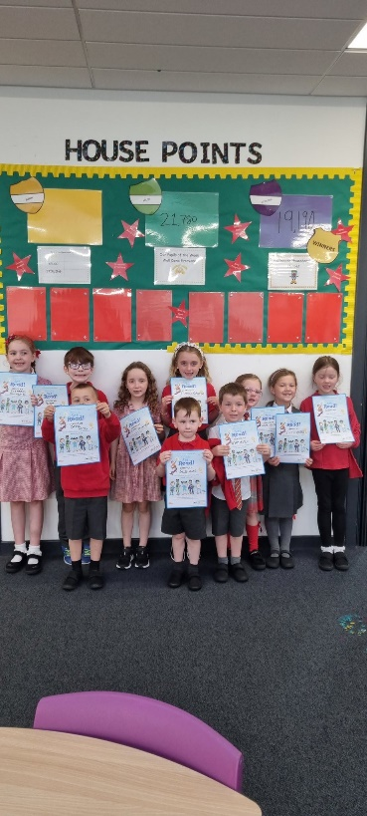

Many pupils across the school participated in the EK Summer Reading programme and received certificates for their efforts.

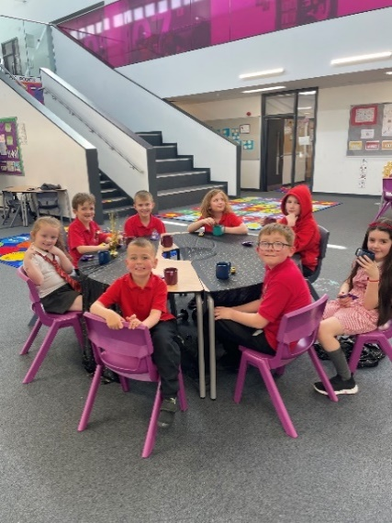
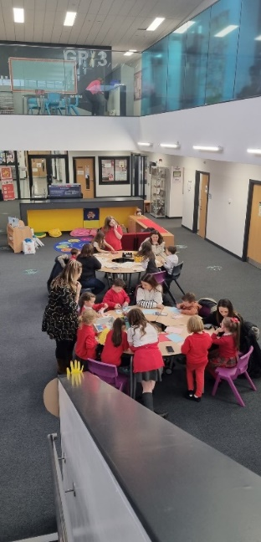
Miss Byrne celebrated pupil achievements with our VIPs.

We hosted a Book Trust Scotland Book Bug Bag gifting event for our P1 pupils

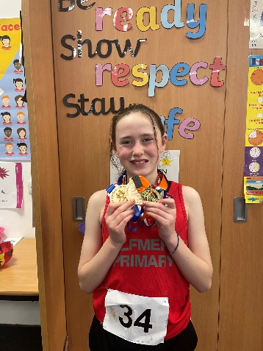
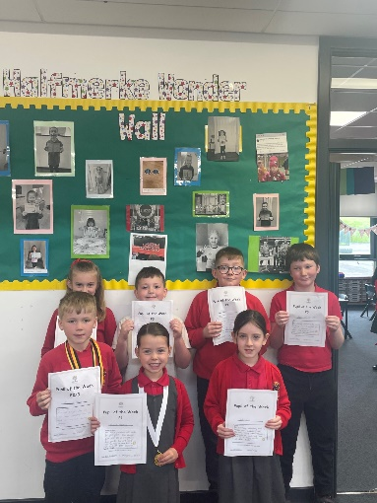
Charlotte was our Cross Country star coming 1st place in the SLC Heats
and 1st place at the Regional Event!

We celebrated lots of Pupil of the Week winners.

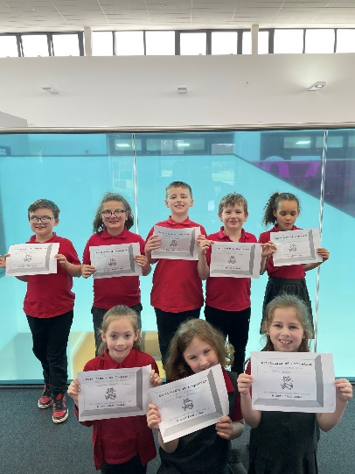
Our staff and parent volunteers held lots of afterschool cluba and activities. Here are our Coding Club with their certificates.

Our Football Stars….
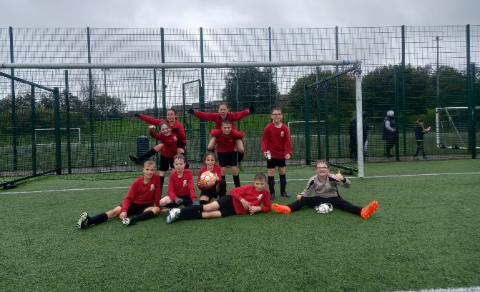

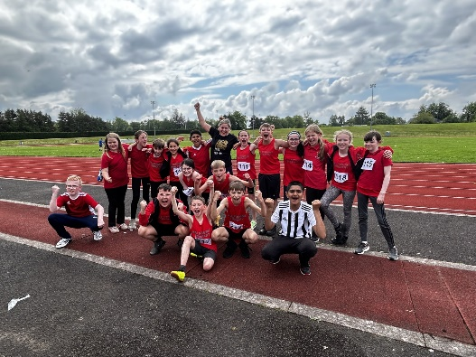
We performed jointly with West Mains Primary in the SLC Dance Showcase.

Our amazing Parent Volunteer took our P6/7 athletics squad to Sportshall Athletics, Cross Country and Track and Field events throughout the session.
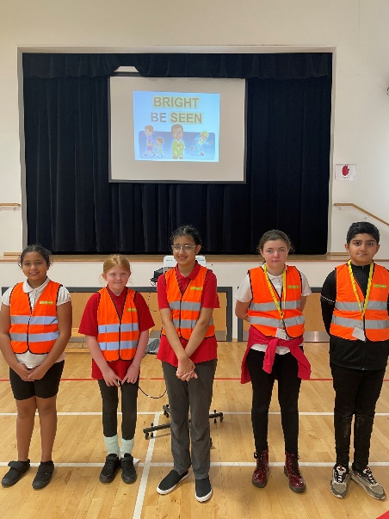

Working jointly with West Mains Primary our JRSO organised our Be Bright Be Seen Event.

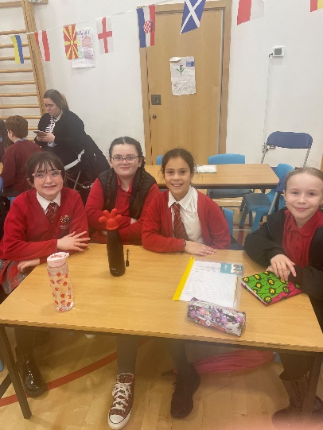

Our talented Euroquiz Team were pipped at the post, coming 2nd in the SLC Heats.

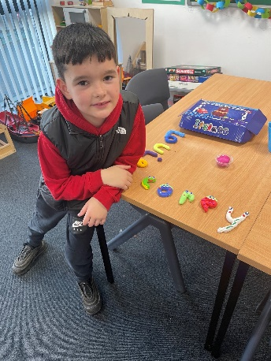
We opened our new shared campus nurture resource
‘The Rainbow Room’

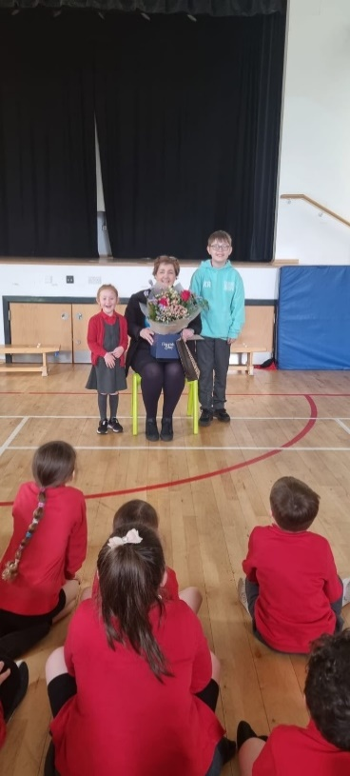

We said goodbye and good luck to our favourite librarian, Rhona.
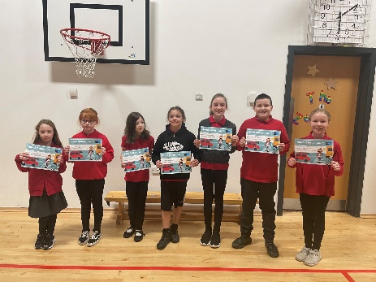

Many of our pupils received certificates for their amazing Road Safety Calendar Competition entries.

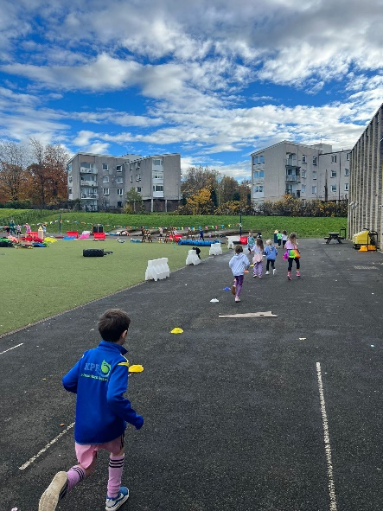
We held our first Dash, Dance or Dawdle to raise monies for our school funds.
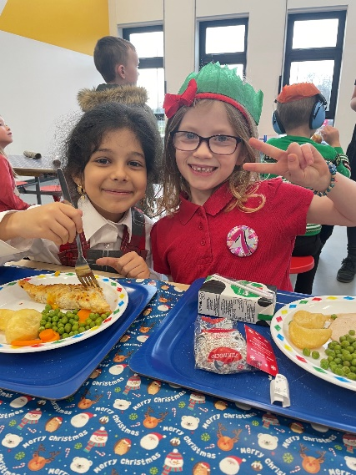

Everyone enjoyed a fantastic festive season, including our favourite Christmas lunch day.

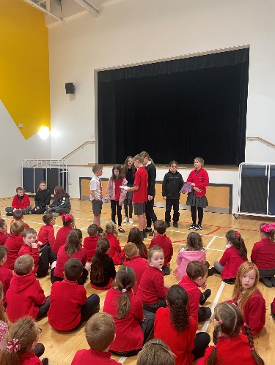

We had many pupil groups this year. Here are our Reading ambassadors and House Captains leading our assembly.

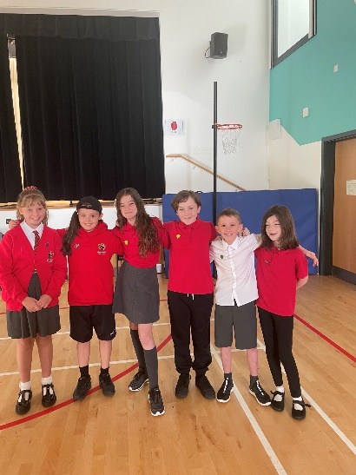
Our House Leaders done a fantastic job, leading their respective houses and collecting pupil views to improve our school.

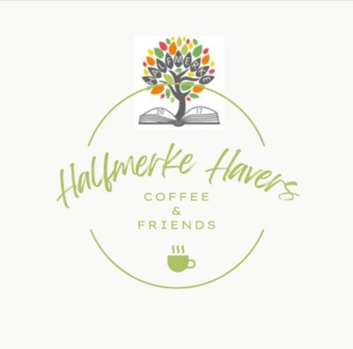

We held monthly Halfmerke Havers sessions were friends and families of Halfmerke could come and blether and share their views.
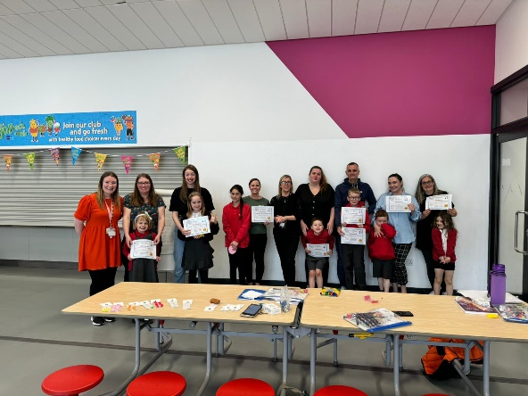

Miss Rankin and Miss Byrne held a successful six week You+Me project working with families to improve maths skills to support our young people.

Context of the school
Halfmerke Primary is a non-denominational school providing education for boys and girls of primary school age. Our school roll is 190 (June 2023) with pupils coming from a wide and diverse catchment area. We have eight classes from P1- P7 with composite classes at P1/2, P2/3 and P3/4. Our staffing compliment is 10.1 teaching staff, which includes the Head Teacher and a Principal Teacher. In addition, we have a support team of 8 people working full or part time to support the learning of our pupils and 2 clerical staff. Janitorial, catering and cleaning staff, working across the three establishments, complete our team.
The ethos of inclusion lies at the heart of our schools, and we promote positive relationships across the three establishments encouraging all pupils to respect themselves and others. Halfmerke Primary and West Mains School work together to promote inclusion between pupils and staff.

School Improvement Plan Priorities2023-24
Priority 1
Improve the confidence and expertise of teachers in their teaching of STEM through participating in the SSERC PCP within our Learning Community
Progress & Impact
- Our STEM Mentor attended training events and participated in SSERC PCP. The mentor has gained an increased understanding in skills and knowledge in STEM/science and has participated in leadership opportunities that have arisen because of this.
- A working party supported initiatives in STEM and development work is currently ongoing.
- We completed an audit of planning and resources in science/STEM
- All staff attended STEM workshops and online SSERC Workshops. All teachers have reported an increased confidence in planning for and implementing teaching and learning in STEM.
- All staff participated in collaborative working at our learning community PL event led by STEM Mentors. All teachers rated this Professional Learning event's overall quality as excellent or very good and agreed that it will impact their future practice.
- Parents were invited to STEM class workshops.
- Our STEM Mentor delivered training for staff at Inset Days. Staff have developed their own skills in STEM.
- All classes have participated in STEM learning opportunities with their class. All learners have engaged in high quality learning in STEM.
Next Steps
Following our involvement in SSERC PCP, staff should continue to embed science/STEM in their curriculum planning, using SLC progression planners and SLC Science Skills Framework. STEM Mentor to continue this lead into next session and provide further training opportunities and support.
Pupil ambassadors will be nominated to ensure pupil voice.
Further parental involvement in STEM/science is necessary for increase community involvement and support for pupils.
Further development of resources is necessary to enhance high quality learning & teaching.
SLC Skills Framework will be used to create links between skills development and STEM.

Priority 2
To explore the unique opportunities for inclusion in a shared campus with ASN and Mainstream schools. To build inclusive practices ensuring progression and all learners are included, engaged, and involved.

Progress & Impact
- Planned joint outdoor learning experiences across both schools using our shared outdoor space. Targeted pupils from both schools gained outdoor learning skills and successfully gained the Silver Woodland Trust Award.
- A whole school assessment tracking spreadsheet created. Halfmerke teaching staff are using a whole school approach to gathering data across Literacy and Numeracy to plan for learning, teaching & assessment. Analysis of data provides staff with greater professional judgement and indicates the requirement for specific interventions to raise attainment and achievement.
- Our Attachment ambassador attended AIP Networking events. Information was shared from these events to our Inclusion working party to raise awareness of AIP and SLC priorities.
- Both schools attended Nurture Training delivered by Susan Tullet. The post input report indicated that 69% of staff Understand the Importance of Nurture in Teaching and 59% are aware that Language is a vital means of communication. Evaluations included statements; good to have practical advice regarding real life situations/working 1-1 with distressed children, very informative and great examples of how to implement strategies. Really made me stop and think about my own practice.
- Shared resources and experiences across campus. Nurture rooms, pamper sessions, Lego Therapy, Sensory Circuits, Deep Pressure Massage. Pupils from both schools collaborate in these shared spaces developing a greater understanding of diversity and needs across the campus. Pupils have developed increased resilience and confidence skills.
- Inclusion across curricular areas in various classes in infant dept. Pupils from both schools have planned sessions to raise attainment in Literacy in Numeracy and opportunities for wellbeing progression.
- We had a joint inset self-evaluation of AIP across both campuses.
- Pupils participated in a joint dance project involving third party provider. HM and WM collaborated at weekly sessions and performed a showcase for parents from both schools. Relationships were forged between pupils of both schools as they collaborated.
- Staff from both schools attended training from Christine Garcia in Deep Pressure Massage and SCERTS. All staff have an increased understanding of the SCERTS model and are more confident in using deep pressure massage as a support tool as and when required.
- SSAs from both schools attended training on Theraputty and Lego Therapy. All SSAs are now able to use Theraputty and Lego Therapy as part of our intervention toolkit.

Next Steps
Although further opportunities will be sought to embed a greater understanding of equity and inclusion within each school and across the campus, it is recommended that this will become part of our establishment maintenance agenda.
Further opportunities for Nurture and inclusion will be included in our PEF Improvement Planning for next session.
Priority 3
Raising attainment in Literacy & Numeracy through implementing a whole school programme for Talk for Writing and Maths Recovery approaches.

Progress & Impact
- RAG rating completed by T4W Leadership group indicates inconsistency of the T4W approach across the school.
- A whole school programme of T4W has developed in collaboration with teaching staff and is beginning to be implemented at all stages. This will ensure a consistent approach to writing across the school.
- Staff surveys have indicated a decrease in confidence in using a T4W approach.
- ACEL data indicates that there is an increase in attainment in writing of 11% (TBC)
- One member of staff has attended The White Book Training. This further training will ensure increased confidence when training staff throughout the school on using this approach.
- All staff attended in-house Maths Recovery training and 25% now have increased confidence in using Maths Recovery approaches to identify and close gaps in maths concepts.
- Attainment in Numeracy has increased by 5.2%
- You+Me parent workshops- survey indicates all parents who were involved in workshops now have confidence in supporting Numeracy at home. Feedback from the post programme survey indicates parents want to continue to be involved in further workshops.

Next Steps
Staff feedback and analysis of data has indicated that further work is required on developing our approach to writing.
A more consistent approach is required, and it is necessary for all staff to receive further professional learning to ensure this consistency.
Following a SLC Literacy event Stephen Graham has visited the school to model the Explicitly Teaching Writing approach. Staff will attend online workshops next session to further develop this approach.
One staff member will attend Maths Recovery Trainee Teachers cohort this session. Part of this role will be to further train staff in maths recovery approaches and for this to be utilised as part of our intervention’s toolkit.
You+Me sessions will continue and be led by the Equity Lead and Maths Recovery Lead next session.
PEF Improvement Planning
Additional staffing of 0.8fte, to allow for Principal Teacher to take the role of Equity Lead and to be non-class committed to facilitate and support Literacy Interventions and a full Nurture Timetable in place from Aug – June.

Progress & Impact
- Boxall profiling indicates a decrease in children with high levels of developmental difficulty overall of 27% compared to the previous year. There is an increase of 13% for those experiencing a high level of diagnostic difficulty due to an increased number of pupils being assessed.
- Those who received nurture provision daily have experienced a move towards lower-level difficulties, achieving targets set. This was a result of embedding nurture principles in all teaching and learning experiences, offering a safe base from which to thrive and accepting all behaviour as communication. Children developed more open and honest relationships with key staff who accepted them “just as they are” using a non-judgemental approach and accepting attitude that helped them to feel safe and secure. Comparison of assessments for these children shows a reduction of 34% experiencing high level developmental difficulty.
- Of the 55 children on IDL intervention, data indicates that all children have made progress in reading and spelling, with almost all children matching or exceeding reading age with chronological age.
- Of the 15 children targeted for 5 Minute Box intervention, 73% have shown an increase in spelling, according to data from NGST results.
- Of the children in the literacy support group in P3, 86% showed improved progress in spelling, using NGST results. SST assessments indicate that all children were making progress in spelling and phonics.
- The range of timely assessments bought using PB has ensured all staff are increasing in confidence when interpreting and analysing data.
- Data is being used by all staff to identify children requiring support/challenge/intervention and all staff are confident in monitoring progress and using data to inform next steps.
- NGRT/NGST/MALT assessments allow effective and robust tracking in Literacy and Numeracy.

Next Steps
It would be recommended that of the children already assessed, seven children continue to receive regular nurture provision next year. Provision should be a mixture of one-to-one sessions, building relationships and developing skills followed by small group opportunities to facilitate application of skills learned.

It may also be beneficial for the Nurture Practitioner to support children in class to ensure consistency in approaches used across the school.

There are other children who have been assessed and were in receipt of weekly nurture sessions through outdoor learning or games-based sessions who would benefit from a different type of provision which facilitates development of strategies related to diagnosed conditions.

Analysis of data indicates progress in IDL, 5 Min Box, Nessy interventions. It is recommended that these will be continued.

PT to remain non class committed as Equity Lead. This will facilitate Maths Recovery, Catch Up Literacy Intervention, You+Me programme, Learning Support for targeted groups of learners at First Level. As Equity Lead the PT will use analysis of data from formal and informal assessments to close the poverty related attainment gap.

School Improvement Plan Priorities 2024-25
- Curriculum
To further embed high quality learning and teaching in STEM priorities across the school: play-based, Interdisciplinary, and real-life and to incorporate skills-based learning.

- Raising Attainment
To increase attainment in literacy and numeracy using Explicitly Teaching Writing Pedagogy and by further embedding Maths recovery Approaches.
- Curriculum
To explore the Refreshed Narrative and the SLC Curriculum Hub to review our curriculum, and to include Rights Based Learning, Sustainability & Equalities, and work collaboratively to refresh our Curriculum Rationale and explore Curriculum Mapping.

- Pupil Voice
To increase meaningful opportunities for impactful pupil voice incorporating STEM, Rights Based Learning, HWB, Sustainability, Digital Learning and Learning & Teaching.

Strategic Priority [insert number]: ____________________________

NIF Priority (select from drop down menus)  Choose an item.  NIF Driver  Choose an item.  Choose an item. | SLC Priority (select from drop down menus)  Choose an item. | HGIOS?4 QIs (select from drop down menus)  Choose an item.  Choose an item.  Choose an item.
Standards & Quality statement – 2023/24

Progress and Impact

Context description

What difference did we see? What did we achieve? How do we know this to be the case? Celebrating success (all from learner perspective)?

Next steps

