Halfmerke Primary School
Standards and Quality Report 2022/23

Context of the school:
Our School: Halfmerke Primary is situated in the East Mains Area of East Kilbride and is within easy access of The Village and the Town Centre. The school enjoys excellent facilities in a fabulous building, which opened in February 2017. Our large campus is home to Halfmerke Primary, West Mains School and Halfmerke Community Nursery. The three schools work together in an inclusive setting. Our inclusive ethos received positive comments from HMIE.

Halfmerke Primary is a non-denominational school providing education for boys and girls of primary school age. Our school roll is 190 (June 2023) with pupils coming from a wide and diverse catchment area. We have eight classes from P1- P7 with composite classes at P1/2, P2/3 and P3/4. Our staffing compliment is 10.1 teaching staff, which includes the Head Teacher and a Principal Teacher. In addition, we have a support team of 8 people working full or part time to support the learning of our pupils and 2 clerical staff. Janitorial, catering and cleaning staff, working across the three establishments, complete our team.

The ethos of inclusion lies at the heart of our schools, and we promote positive relationships across the three establishments encouraging all pupils to respect themselves and others. Halfmerke Primary and West Mains School work together to promote inclusion between pupils and staff.

We aim to ensure that every child has a broad and general education with literacy, numeracy and health and wellbeing at the centre of our curriculum. We value meaningful learning for all our pupils and our aim is that every child is supported to reach their potential both in their academic learning and wellbeing by providing them with a range of activities and opportunities in all curricular areas.

You will find us in a fantastic, award-winning building designed to enhance our ethos of inclusion. Inside is bright and inviting with break out areas for the children to work in small groups or independently. We are also fortunate to enjoy extensive grounds, which are utilised for learning opportunities as well as for play. Our learners have supervised access to the local community and the town centre, allowing us to access the central library and swimming pool.

Halfmerke Primary is committed to working with families and work closely with our Parent Council who support us in school improvements and fundraising.

We are committed to raising attainment of all learners and have focus on raising attainment in literacy and numeracy as well as promoting and supporting wellbeing for all. We endeavour to fully support pupils through early indicatication and ensuring appropriate interventions are in place.

We want our pupils to become Confident Individuals, Successful Learners, Responsible Citizens and Effective Contributors and we support each one to be the best they can be.
Our school rules are to
Be Safe
Be Respectful
Be Ready

And we place importance on our shared school values to promote a safe, inclusive and positive environment for all staff and pupils.

Respect Honesty Trying our Best Friendships Inclusion

‘Working and learning together to achieve excellence’

Some Highlights of Session 2022/23
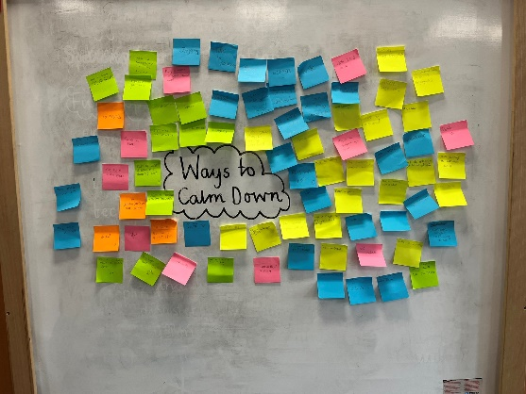
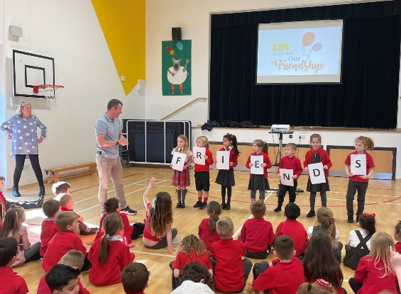
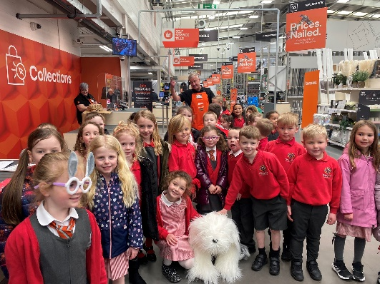
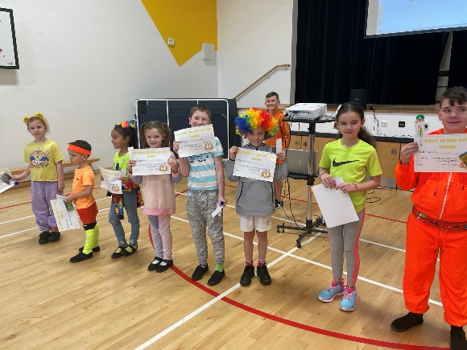
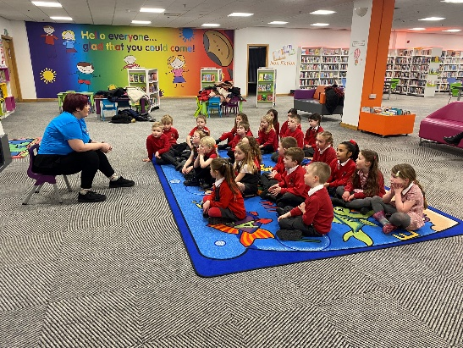
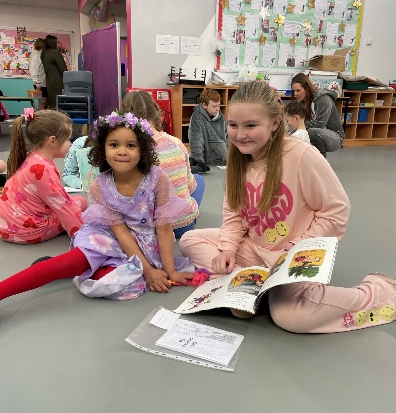
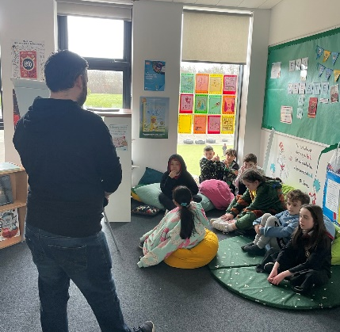
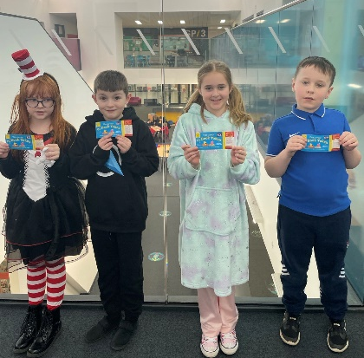
Rooms 1 & 2 went on a trip to B&Q to get help with their Gardening Project
Our JRSO’s held a Wear it Bright Day!
Every class visited Rhona at EK Central Library
We enjoyed assemblies with Mr Cairney
Our new PATHS programme helps us with our emotions.
Mr Tonner ran our fabulous Coding Club!
We celebrated World Book Day
Mrs Bonner’s Nurture Groups enjoyed trips out of school.

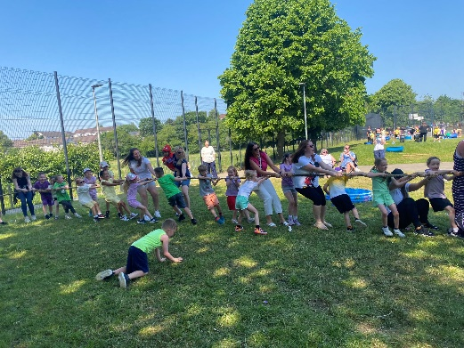
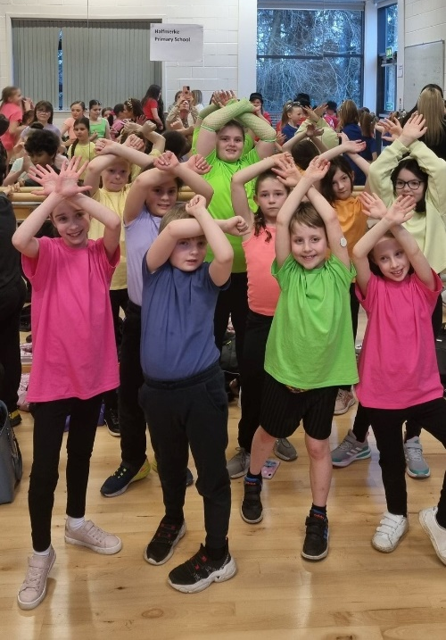
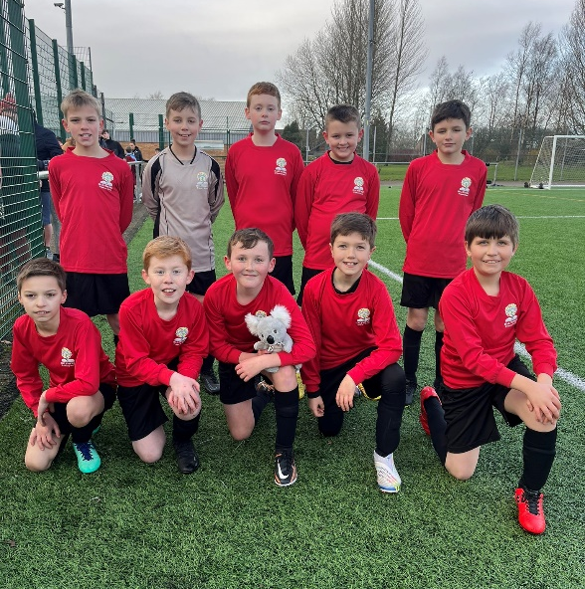
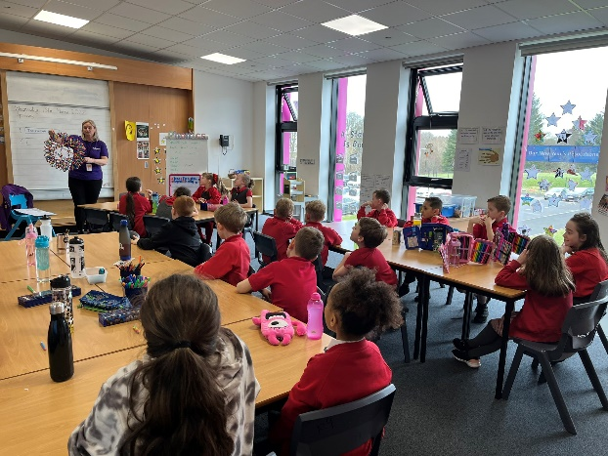
Angela from Mind Marvels helped us with our focus and concentration.
We all enjoyed a sunny sports day!
New strips for our Football Squad. They had lots of success this year.
Our dance crew performed at the LC Showcase event.
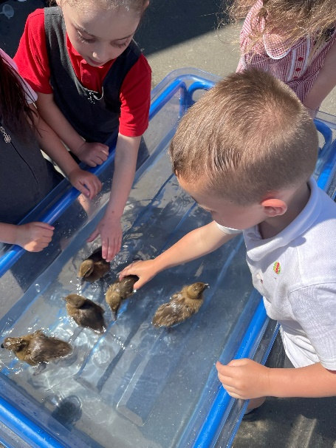
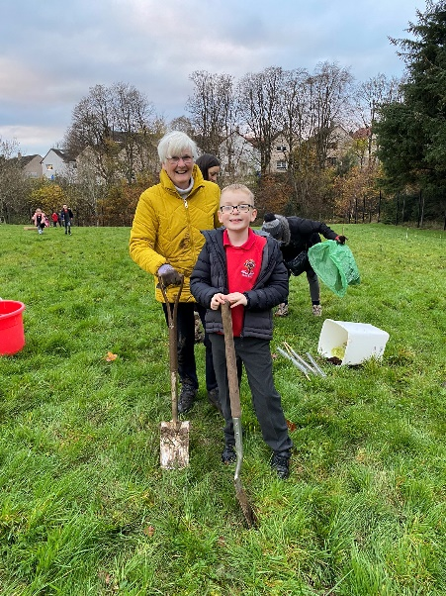
Rooms 1 & 2 successfully looked after and hatched some Duck Eggs.

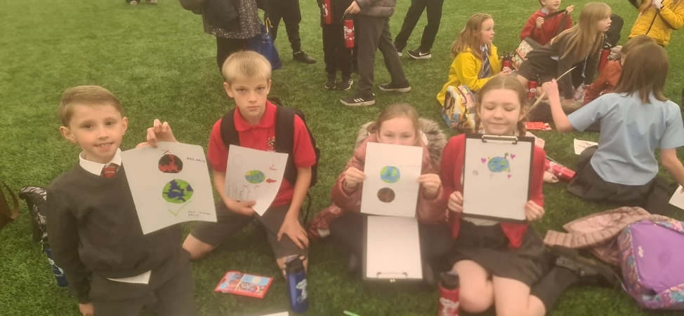
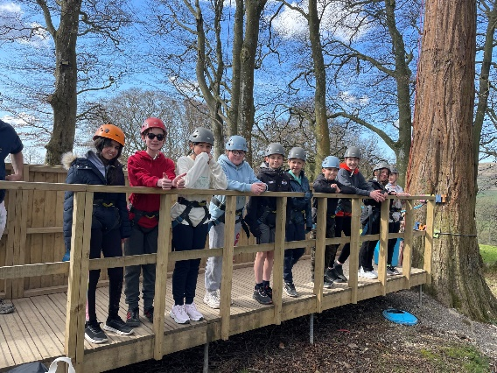
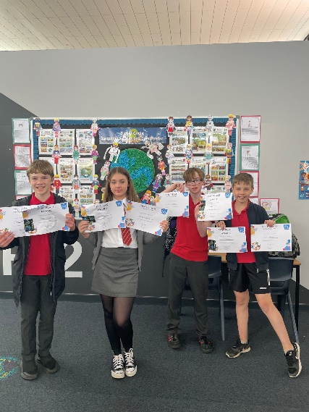
Our Climate Ambassadors attended the SLC Tiers Event
Room 8 had an amazing time on their residential trip to Robinwood.
Room 7 wrote, produced and performed their own version of Oliver.
Our Maths Geniuses won the LC Maths Competition!
We got involved in a joint project planting trees with West Mains School.
Everyone enjoyed our Open Afternoon, lots of families came along.

Review of progress for session Aug 2022- June 2023
School priority 1: Raising attainment in literacy and numeracy through approaches to teaching and assessment and moderation

NIF Priority (select from drop down menus)  Improvement in attainment, particularly in literacy and numeracy.  NIF Driver  Curriculum and assessment  Teacher professionalism | HGIOS?4 QIs (select from drop down menus)  3.2 Raising attainment and achievement  2.2 Curriculum  - 2.3 Learning, teaching and assessment
Strategy
What did we set out to do?

- A programme of review for TFW including an audit of all stakeholders, moderation of teaching, learning and assessment including peer, trio visits with subsequent professional dialogue.
- Teacher CLPL – One staff member to attend Maths Recovery Training and for this to be rolled out to all teaching staff.
- Programme of Literacy & Numeracy Catch up and 5 Min box and IDL to be delivered to targeted pupils.
- Continue to sustain and embed improvements in reading by developing a reading culture across the school and ensure that appropriate interventions are in place.
- Talking & Listening Policy to be created for all stages.
- School to continue to develop and sustain initiatives for Reading School Accreditation.

Progress and Impact
What difference did we see? What did we achieve?

- One CT fully trained in Maths Recovery.
- All teaching staff have participated in a CAT session and half day inset training on Maths Recovery.
- Maths Recovery has been delivered to a targeted group of learners at P4 and P5.
- Increased confidence in teaching, assessing and intervention strategies within numeracy and mathematics.
- HT, PT and CT attended Talk 4 Writing Leadership training.
- A Leadership Team to embed T4W was set up. The team RAG rated our approach with teaching staff to raise literacy standards.
- A whole school planning approach was developed for Talk 4 Writing. This will ensure consistency of planning, teaching and assessment of T4W across the school.
- A programme of Literacy and Numeracy Catch up interventions and 5 Min Box were implemented across the school and assessed to track learners progress to inform next steps. Interventions benefitted targeted pupils to raise attainment in Literacy and Numeracy.
- Promoting a culture of reading for pleasure was embedded across the school.
- Reading Ambassadors were established.
- Classes were timetabled for library time.
- All classes visited the local library, and all pupils have their own library card.
- A paired/buddy reading programme was established with P1, P2 and P6.
- P6 pupils were involved in paired reading with Halfmerke Community Nursery.
- We celebrated World Book Day.
- We participated in Book Week Scotland and had a Book Bug Bag gifting event with parents attending.

Next Step(s) to inform SIP for 2023/2024:

Teaching staff to use Maths Recovery approaches to inform planning and next steps for targeted pupils.

Working group to be set up to ensure Maths Recovery approaches are embedded in classroom practice and moderation of Maths Recovery lesson plans.

Workshops for families to increase parental confidence and consistency in using Maths Recovery approaches to numeracy.

Whole school planner ensure consistency in T4W.

Moderation in writing across levels and SLT to Quality Assure a consistency of approach.

To continue to sustain and embed Reading for Pleasure and apply for Gold Reading Schools Accreditation.

School priority 2: Developing a Whole School Nurturing Approach

NIF Priority (select from drop down menus)  Improvement in children and young people’s health and wellbeing  NIF Driver  Teacher and practitioner professionalism  Choose an item. | HGIOS?4 QIs (select from drop down menus)  3.2 Raising attainment and achievement  2.3 Learning, teaching and assessment  2.2 Curriculum
Strategy
What did we set out to do?

- Staff CLPL in Pivotal Behaviour Approach
- Nurture Audit to include all stakeholders.
- Continue to embed SLC Attachment Strategy.
- Nurture Groups set up.
- HWB Ambassadors to led and support a whole school coordinated approach.
- Develop a Nurture Policy for consistency of approach across the school.

Progress and Impact
What difference did we see? What did we achieve?

- Health and Wellbeing staff and pupil ambassadors were established. This provided a coordinated whole school approach to HWB.
- Pupil HWB Ambassadors set up buddies for targeted children to check in and address and HWB concerns, directing them to an adult where necessary.
- Nurture teacher and CTs worked collaboratively, using Boxall Profiling to identify pupils who would benefit from participation in a Nurture Group. Individual targets were identified for targeted pupils.
- A new Nurture space was created within the school and resourced using school and PEF budget.
- Nurture groups were established for targeted groups of pupils according to developmental needs.
- Staff and parents have engaged with the SLC Attachment Strategy and have identified strengths and developmental needs within the school. These will form part of our work on Attachment Strategy next session.

Next Step(s) to inform SIP for 2023/2024:

Consultation is still underway to gather feedback from Staff, Pupils and Parents on Nurture at our school. This is still ongoing.

To further embed Attachment informed practice across the school and our parents.

School priority 3: Building an inclusive environment to raise attainment and achievement for all

NIF Priority (select from drop down menus)  Closing the attainment gap between the most and least disadvantaged children and young people  NIF Driver  Teacher and practitioner professionalism  Parental engagement | HGIOS?4 QIs (select from drop down menus)  3.1 Ensuring wellbeing, equality and inclusion  3.2 Raising attainment and achievement  2.4 Personalised support
Strategy
What did we set out to do?

- Staff CLPL in PPRUDB & Staged Intervention
- Class profiles to be created
- Programme for Inclusion with West Mains School
Procurement of resources to ensure Equity for all – Pupil Learning packs issued where necessary
- Participatory Budgeting group set up
Parent workshops to focus on support of learning and HWB
- Revise and review schools COSD position statement
- Continue to build on Schools Attendance Initiative

Progress and Impact
What difference did we see? What did we achieve?

- All staff participated in PPRUDB CLPL and continue to embed this approach in their daily practice.
- All staff are aware of PPRUDB paperwork, and this is in place for specific pupils across the school.
- Teaching staff received a refresh of SLC Staged Intervention procedures. A targeted approach is now in place to identify pupils who require additional support.
- Templates have been shared to create class profiles for each stage identifying ASN, SIMD and targeted interventions.
- Participatory Budgeting stakeholder group was identified, and a coordinated approach was used to identify our PB spend.
- PB was used to procure playground resources. We saw a decrease in playground incidents because of this.
- A programme of Phonological Awareness and Active Literacy workshops was set up for targeted learners in the early years. There was around an 80% uptake in this.

Next Step(s) to inform SIP for 2023/2024:

Continued focus on revising our COSD position statement in line with SLC priority for a COSD policy.

Continue to build on School Attendance Initiative.

Class profiles to be created for each stage.

National priority: How we are ensuring Excellence and Equity?

Strategy
Brief commentary on context and identified barriers to learning which affect progress and attainment, key interventions undertaken

- Mixed Catchment of affluent new housing development and LA housing.
- 22% of pupil receive FME.
- Currently, we have no pupils living in SIMD 1&2 and 4% living in SIMD 3.
- Our Pupil Equity Funding allows the PT to be non-class committed taking the role as equity lead.
- When analysing the Poverty related attainment gap, this is greater in Reading, 11% and Writing, 18% than in Numeracy, 6%. Attendance figures indicate a gap of -5.6% (based on 2020-21 Data)
- PEF funding was used to purchase the Mind Marvels programme. This was delivered to all classes weekly from April onwards.
- Barnardos PATHS Programme was introduced after Christmas.
- PEF funding was used to purchase resources for our new sensory room.
- Halfmerke Havers sessions were introduced monthly to encourage parental engagement.
- Participatory Budgeting Funding was utilised to purchase playground resources.

Progress and Impact
What difference did we see? What did we achieve?

- An increased awareness and confidence in problem solving and resilience strategies in almost all pupils.
- Staff are more confident in delivering a programme of emotional wellbeing.
- Increased attainment levels in Literacy and Numeracy were observed during tracking and monitoring dialogue.
- Increased engagement in lessons from identified pupils.
- Decrease of playground incidents as a result of playground equipment and PATHS programme.

Next Step(s) to inform SIP/PEF Plan for 2023/2024:

PEF used to ensure Equity Lead is non class committed in session 2022-23

Ensuring a whole school nurturing ethos to be a focus.

Supporting and engaging with families.

