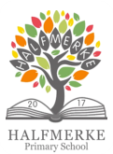

‘**Working and**

**Halfmerke Primary School Improvement Plan 2022-2023**

Each learner in Halfmerke is unique bringing their own support needs, talents and interests. We support each learner to engage with learning in all aspects of the curriculum and to be the best they can be. Our School Improvement Plan describes how we will work together to make Halfmerke a better place for all pupil’s learning. Here is a summary of work we will be developing this year.

**learning**

**together to achieve**

**excellence’**

**Our Maintenance Agenda**

More work to do on

**Our Improvement Agenda**

**We are working hard to get better at………**

